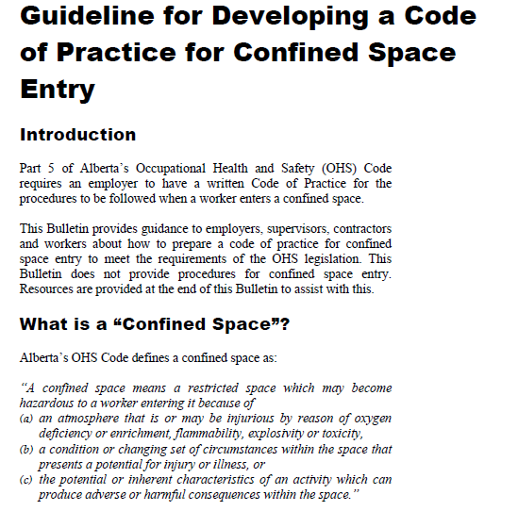

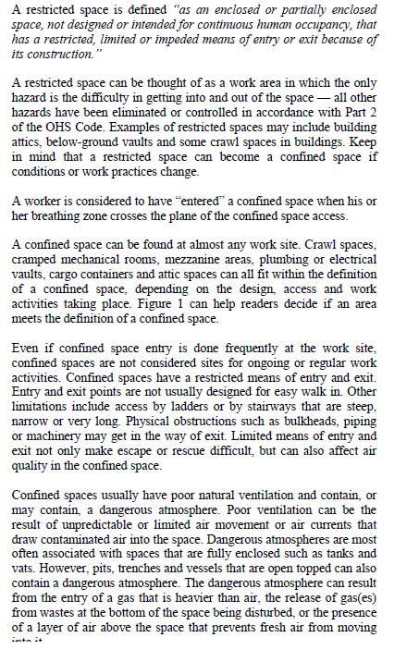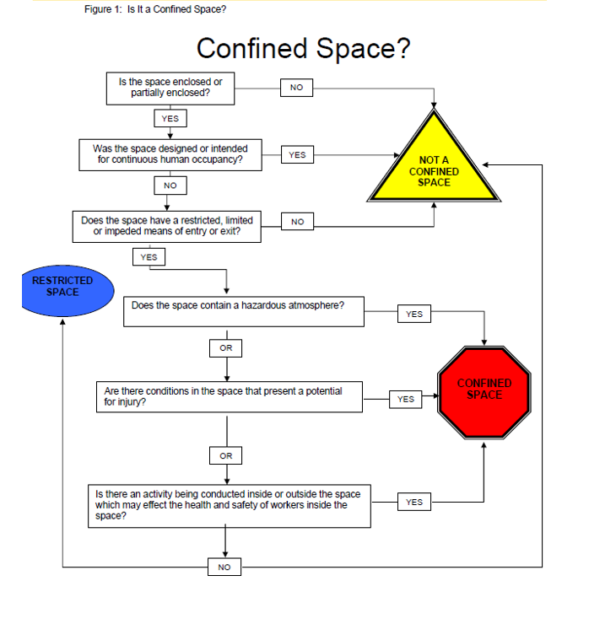

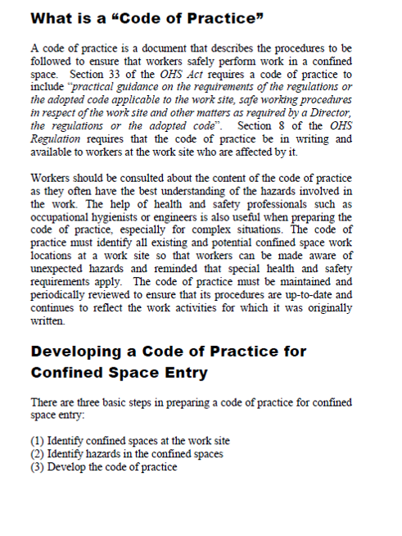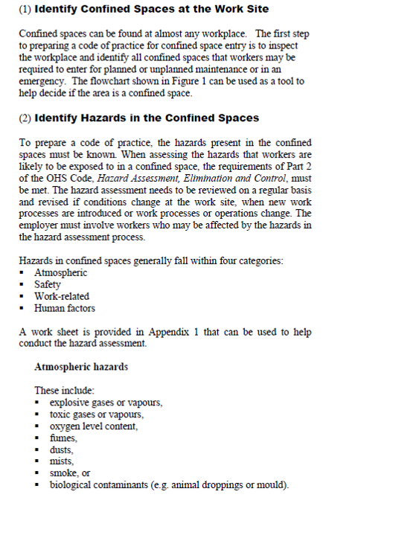

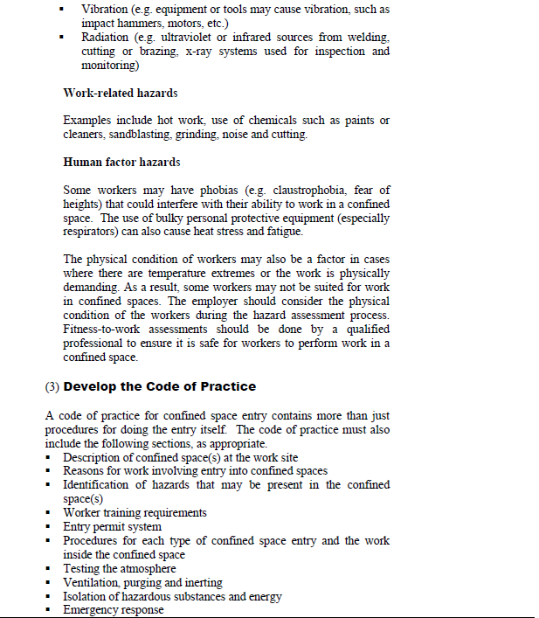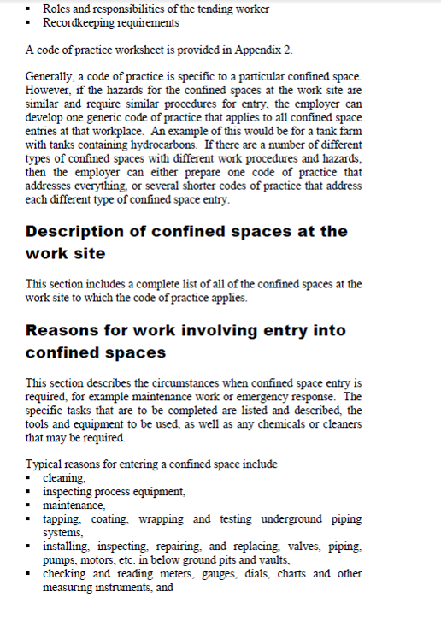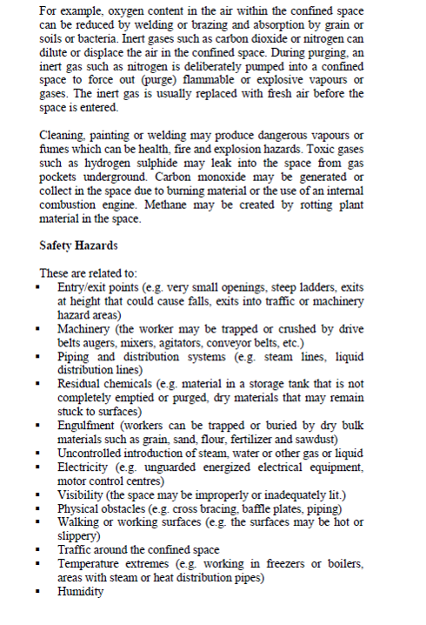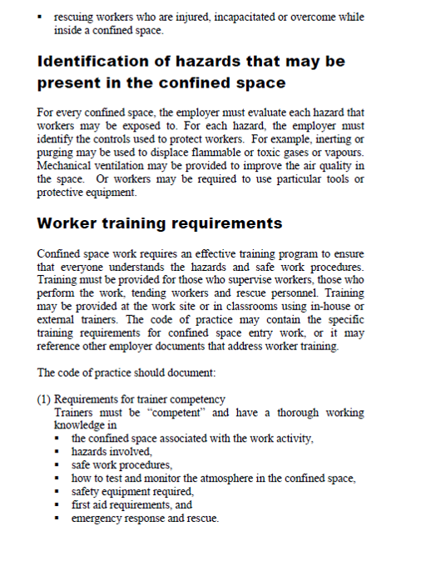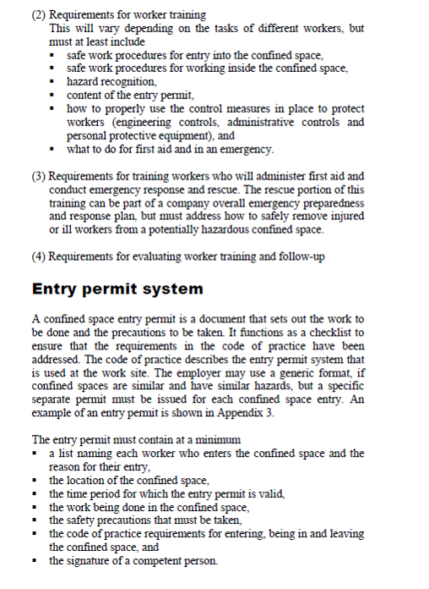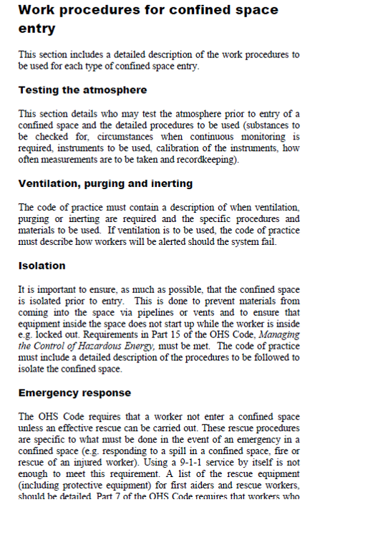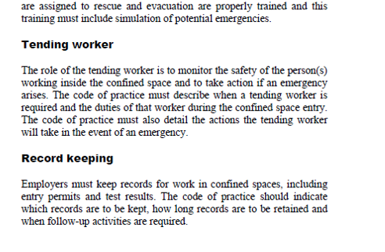

CONFINED SPACE ENTRY CODE OF PRACTICE

This policy and procedure is established to ensure Delta Springs employees and sub-contractors

are adequately protected while working in confined spaces. If DELTA SPRINGS employees are

required to enter a confined space while contracted by a client who has an existing

confined space entry procedure, the procedure of that client will be followed. This policy

and procedure is for low and moderate hazard atmosphere confined spaces. Under no

situation should DELTA SPRINGS employees enter and work in high hazard atmosphere

confined spaces.

This confined space entry program is written to safely address commonly encountered

aspects of confined space entry and to provide guidance on meeting general provincial

Health and Safety Legislation. It is stressed that precise safe work requirements for

confined space entry will vary with federal or provincial jurisdiction and from one

situation to the next. Confined Spaces can be found part 5 of Alberta OH&S code.

RESPONSIBILITIES

• DELTA SPRINGS shall ensure that potential confined spaces are identified and that all confined

space hazards are eliminated or minimized and that work is performed in a safe

manner. DELTA SPRINGS Management will also review this procedure on an annual basis to

ensure it is up to date and accurate.

• Project Managers, Site Superintendents and/or Sub-Contractor Supervisors must

ensure that a JSA and Hazard Assessment Form are completed with employees, that

pre-entry testing and inspection is conducted based on written procedures,

precautions identified in this procedure are followed, and only authorized workers

enter a confined space.

• Each person who is assigned duties and responsibilities related to entry into a

confined space must be adequately trained in the hazards of the space and precautions

outlined in written work procedures to properly perform their work.

DEFINITIONS

These definitions are taken from Part 9 –Confined Space – Occupational Health and

Safety Regulations, WCB, BC.

• Confined Space – means an area, other than an underground working, that (a) is

enclosed or partially enclosed, (b) is not designed or intended for continuous human

occupancy, (c) has limited or restricted means for entry or exit that may complicate

the provision of first aid, evacuation, rescue or other emergency response service, and

(d) is large enough and so configured that a worker could enter to perform assigned

work.

• Low hazard atmosphere – means an atmosphere which is shown by pre-entry testing

or otherwise known to contain clean respirable air immediately prior to entry to a

confined space and which is not likely to change during the work activity, as

determined by a qualified person after consideration of the design, construction and

use of the confined space, the work activities to be performed, and all engineering

controls required.

• Moderate hazard atmosphere – means an atmosphere that is not clean respirable air

but is not likely to impair the ability of the worker to escape unaided from a confined

space, in the event of a failure of the ventilation system or respirator.

• High hazard atmosphere – means an atmosphere that may expose a worker to risk of

death, incapacitation, injury, acute illness or otherwise impair the ability of the

worker to escape unaided from a confined space, in the event of a failure of the

ventilation system or respirator.

• Clean Respirable Air – When used to describe the atmosphere inside a confined

space, means an atmosphere which is equivalent to clean, outdoor air and which

contains…(a) about 20.9 % oxygen by volume, (b) no measurable flammable gas or

vapour as determined using a combustible gas measuring instrument, and (c) no air

contaminant in concentrations exceeding either 10% of its applicable exposure limit

or an acceptable ambient air standard, whichever is greater.

CONFINED SPACE ENTRY – WORK PROCEDURES

Where reasonable practicable, DELTA SPRINGS will use an alternate means to perform work that will

not require a worker to enter a hazardous confined space.

• JSA and Risk Assessment – Before work begins in a confined space, the site

superintendent/sub-contractor supervisor will complete and review a JSA and Risk

Assessment with all employees involved in the project. The potential hazards in the

confined space must be reviewed. This could include atmospheric contaminants,

poor lighting, electrical hazards, mechanical hazards, and slip/trip/fall hazards.

• Pre-entry testing and testing during work activities - Before entry into confined

spaces with a low/moderate hazard atmosphere, the space must be tested for oxygen

content and flammable concentration using an atmosphere testing device, commonly

known as a 4gas monitor. Instrument must contain sensors for oxygen, lower

explosive limit (LEL) CO, and hydrogen sulfide. All gas testing records must be

posted at the entrance to the space. Completed records should be filed as part of

the project close-out. Continuous testing should be completed by utilizing a

multi-gas testing device during the entire period of work, wherever possible. If

not possible, then testing must be completed upon exiting and re-entering the

space.

Oxygen Content - oxygen concentration must be maintained between 19.5% and

23% by volume. Normal oxygen concentration in air is approximately 21% by

volume in air with nitrogen comprising almost the remaining 79%.

Flammable Gases/Vapours - know the gas/vapour present. The LEL are

different for each gas/vapour. A concentration above the LEL is explosive.

• Flammable gas/vapour levels must be kept at or below 20% of the LEL. If

levels get above 20%, then work will cease, workers inside the space will

immediately vacate and notify project manager. Work shall not commence in the

space until flammable levels are below 20% of the LEL.

• Personal Protective Equipment (PPE) - The working conditions within the

confined space will dictate the requirements for personal protective equipment. As

requirements will vary widely, it is best to refer to applicable MSDS's of any

chemicals used for appropriate PPE (e.g. gloves, monogoggles).

• Tasks would continue to utilize appropriate PPE for working in non-confined spaces

(i.e. asbestos removal). However, consideration should be given to potential build-up

of contaminants such as welding fume or solvent vapours. Site Superintendents/SubContractor Supervisor may consider the use of local exhaust ventilation to extract the

contaminant at the source.

• If respirators are intended to be used, it is very important that the right respirator for

the job be selected. The DELTA SPRINGS Respiratory Protection Program should be followed.

• Man Watch – If DELTA SPRINGS employees are required to enter a confined space a man watch

is required to be at the entrance of the confined space and be able to communicate

with the worker inside the confined space.

• Emergency Procedures and Equipment

Access and Egress - The opening of a confined space must be large enough to

permit the entry and exit of employees wearing the required PPE and the space

must be kept free of obstructions. Doors and latches must be secured in the open

position and locked so that they cannot accidentally be closed and trap a worker

inside the space. All ladders, scaffolds, etc. necessary to gain access/egress to the

work area must be secured.

No entry is allowed if a possibility of a cave-in or shifting material/equipment

exists where a worker could be buried or trapped.

Rescue - If rescue is necessary (worker injury), workers outside of the space will

first summon help (phone 911 if life-threatening, project manager if not life

threatening), then will attempt a physical rescue only if the cause of the injury is

known and conditions in the space will not affect those entering the space (for

example; worker fell and broke leg). No one will enter the space until a nearby

worker has arrived at the entrance to the space to assist. If, at any time, a worker

in the space is unconscious for no recognized reason, no one will enter the space

until emergency crews arrive.

Training

All DELTA SPRINGS staff working in confined spaces will be required to have completed confined

space training (recommended 1 day course), respirator training and fit testing, calibration,

use and limitations of the gas tester and use of personal protective equipment.

